The Speaking Clock – A Post Office Film
“The time is 3:19 …..x3” Ph: 1194
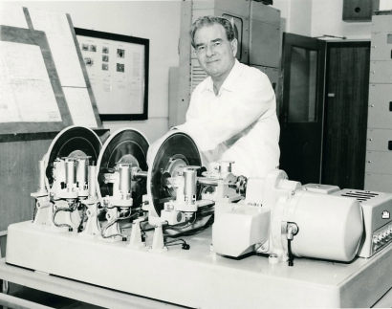

Thousands of times a day in Melbourne alone,telephonists,until recently,spoke into an ever demanding microphone,providing for subscribers an accurate Time-of-Day service.
But now the manual system has been replaced by robot equipment.
“The time is 10:32”
Australia's first speaking clock came to Melbourne in the Liner “Arcadia” on her maiden voyage to this country. Contained in 37 crates,it was carefully unloaded under the supervision of Post Office Engineers.

At the same time,Sydney received its speaking clock – automatic equipment which gives the time every 10 seconds,day and night and which,if need be,could answer 600 enquiries simultaneously.

In other Capital cities too,as the subscriber demand grows,similar automatic equipment will be installed.

(Note – “Clearance 12' 6” = 12 feet,6 inches . and “Handle with Great Care” on Crates)

The task of installing the clocks,each weighing many tons,began under the supervision of a British Post Office engineer whose care guided Australian technicians through the intricacies of assembly in specially prepared rooms.

The mechanism itself comprises two complete units,one working and one standby,each connected to a different source of power supply in order to safeguard against a breakdown in the service.

In operation,3 glass discs,each revolving 30 times per minute,carry a photographic record of the announcement,similar to the soundtrack on a motion picture film.

The announcements are arranged in concentric circles on the discs and are scanned by means of a photo-electric cell and lamp placed on opposite sides of the disc.

The changeover in the time-service from live announcements to automatic was made in both Sydney and Melbourne in November 1954.

“.. at the 3rd stroke it will be 9:50 and 10 seconds
at the.....”
The clocks are accurate to 100 parts of a second and each is checked against a Master Clock housed in the Post Office Research Laboratories in Melbourne,which in turn is itself checked daily against the Standard Chronometer maintained by the Commonwealth Observatory at Mt Stromlo near Canberra.

The complete announcement is broken into sections -part only being carried on each disc.

“ at the third stroke it will be 10:27 and 10 seconds...beep,beep,beep
at the third stroke it will be 10:27 and 20 seconds...beep,beep,beep
at the third stroke it will be 10:27 and 30 seconds...beep,beep,beep “

A cathode ray oscilloscope is incorporated into the equipment so that the technician may check visually any variation in the working clock from Standard Time.

And now, on the twist of a dial the robot machine tells us the time,24 hours of the day,a new time signal every 10 seconds.

It brings the Australian Time-of-Day Services into line with the most modern development in the world.

It's another Service brought to you by the Post Office.

“....At the 3rd stroke it will be 10:28 precisely”

-------------xxxxxx-------------

